|  |  |  |  |
| --- | --- | --- | --- |
| **paf_kiet_logo** | **COLLEGE OF COMPUTING AND INFORMATION SCIENCES** | | |
| **Final Assessment of Lab Exam (SUMMER 2021 Semester)** | | |
| **Class Id** | 107241 | **Course Title** | OPERATING SYSTEM LAB |
| **Program** | BSCS | **Campus / Shift** | MAIN/ MORNING |
| **Date** | JULY 15, 2021 | **Total Marks** | 20 |
| **Duration** | 02.30 HOURS | **Faculty Name** | UBAID ULLAH |
| **Student Id** | 11146 | **Student Name** | HAMMAD MURTAZA |
| **Code** | **A** |  |  |

**Instructions:**

* Fill out your Student ID and Student Name in above header.
* Do not remove or change any part question paper.
* Write down your answers with title “Answer for Question# 00”.
* Handwritten text or image should be on A4 size page with clear visibility of contents.
* In case of CHEATING, COPIED material or any unfair means would result in negative marking or ZERO.
* Viva can be taken with prior notice, where deemed necessary.
* **Caution:** Duration to perform Final Assessment is **02 hours only and 30 minutes** are given to cater all kinds of odds in submission of Answer-sheet. **Therefore, if you failed to upload answer sheet on LMS (in PDF format) within 2.30 hours’ limit, you would be considered as ABSENT/FAILED.**

Q1: : Write a C program to implement the **Optimal page replacement algorithm**. Use this Reference String 7 0 1 2 0 3 0 4 2 3 0 3 2 1 2 0 1 7 0 1 and set Frame size=4.

1. Find the **Miss ratio and Hit Ratio** for using formulas provided below:
   1. Miss Ratio = (Total No. of Page Faults / length of reference string)\*100
   2. Hit Ratio = (Total No. of Page Hits / length of reference string)\*100

(5 Marks)

ANSWER:

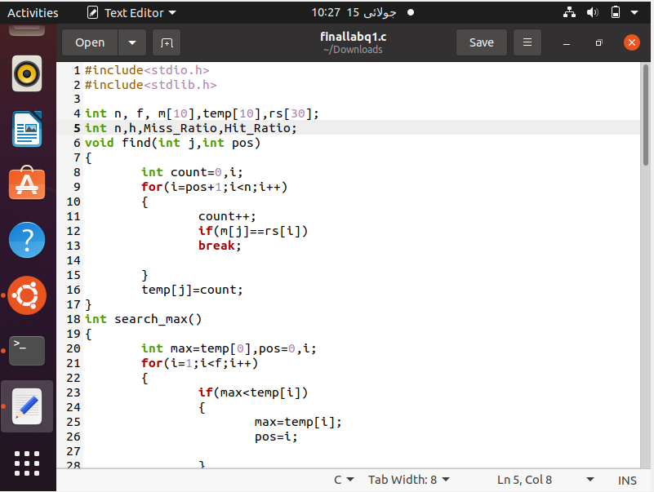

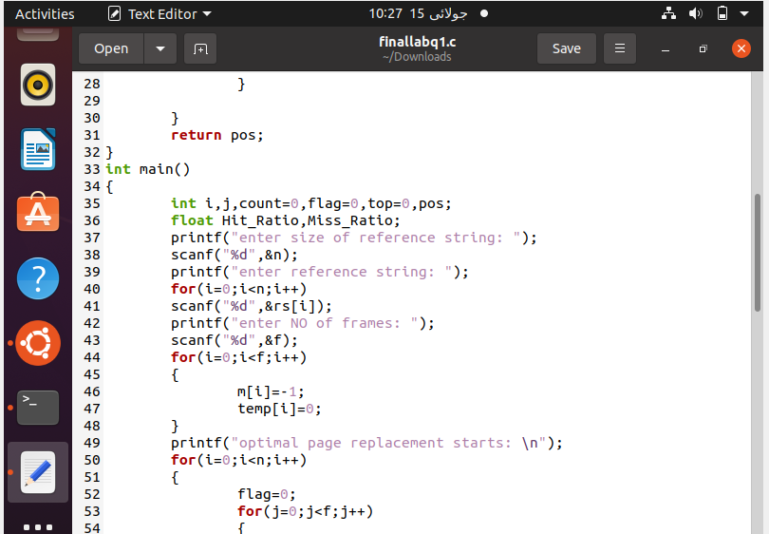

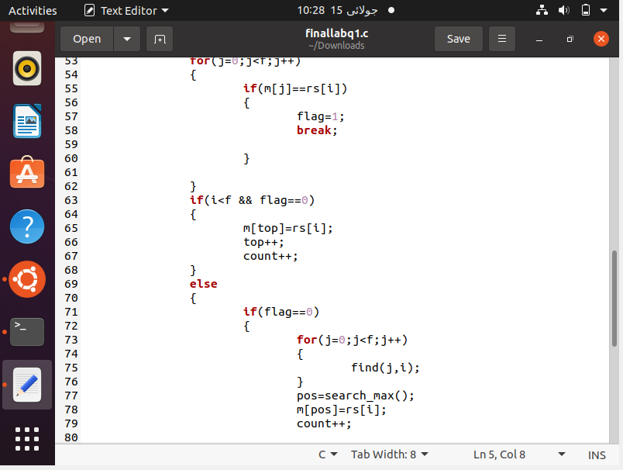

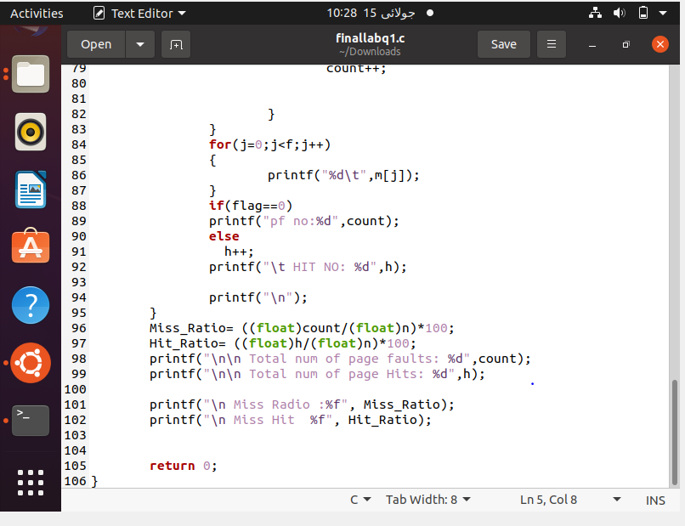

OUTPUT:

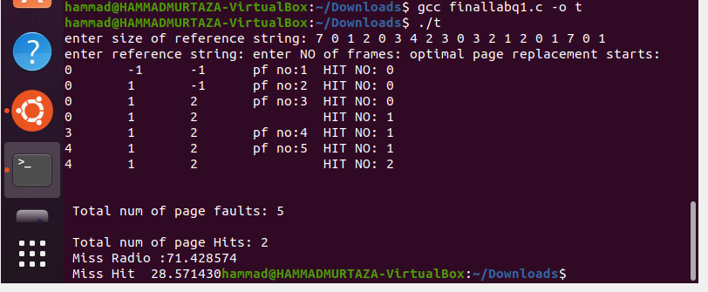

Q2: Write a C program to implement Inter Process Communication using **Named pipes**.

1. Server ask user to input 5 integer values and write in the pipe.
2. Client read from the pipe and sort them.
3. Client write sorted values in the pipe.
4. Server read the sorted values and print them.

(5 Marks)

ANSWER:

CLIENT:

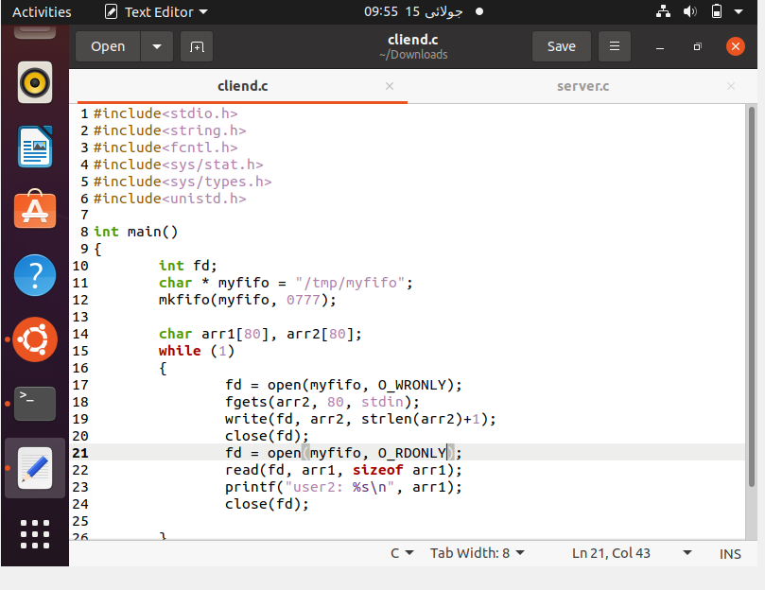

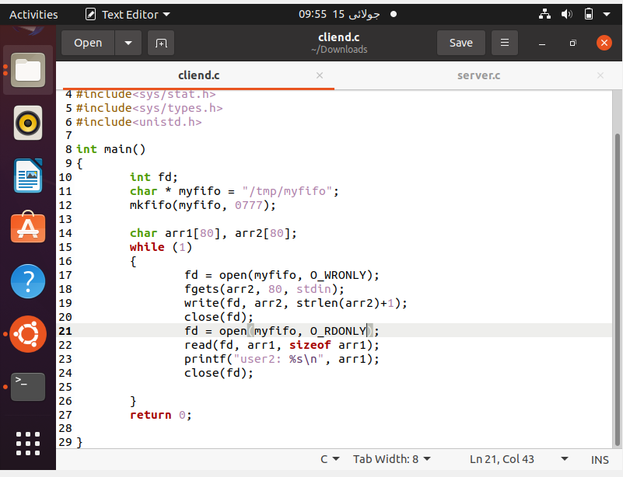

SERVER:

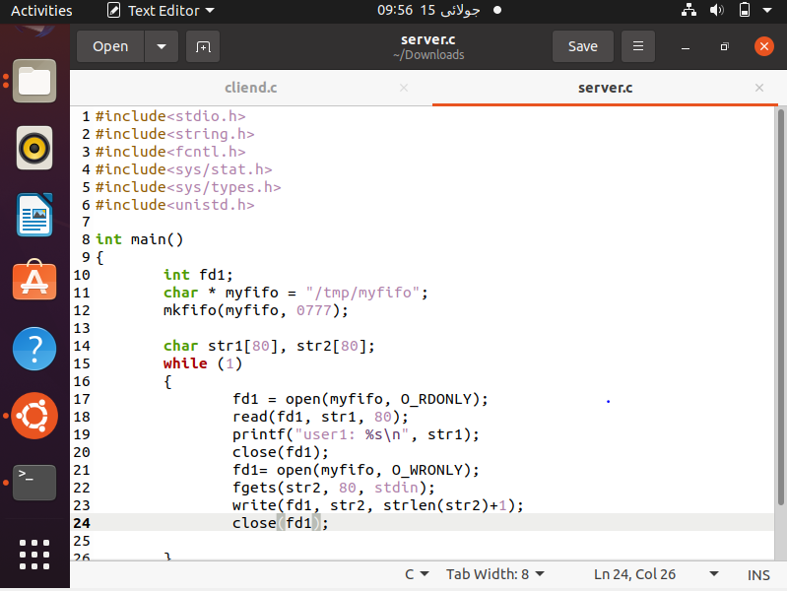

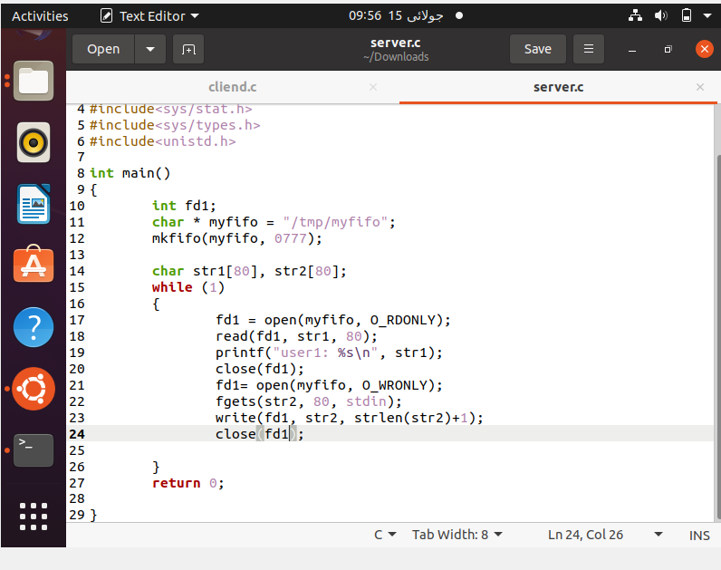

OUTPUT:

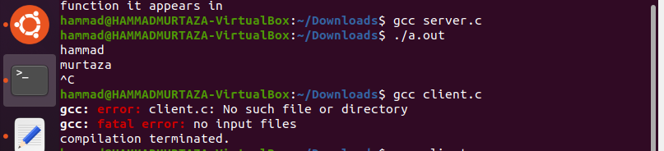

Q3: Write a C program to implement **threading**.

1. Use following two Arrays
   1. Student ID[]={101,102,103,104,105}
   2. Student Results[]={85,45,55,65,75}
2. Thread1 prints the studentIDs of those students who has 1st and 2nd highest marks.
3. Thread 2 prints the IDs of failed students (whose marks are less than 60)
4. Thread3 prints avg marks of the class.

Note: Use Mutex to avoid race condition. (10 Marks)